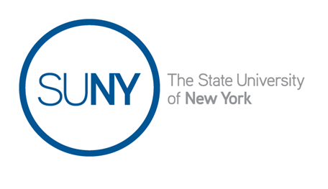
Dr. Edelmira Reynoso serves as the Diversity Program and Research Associate for the Office of Diversity, Equity and Inclusion (ODEI) at the State University of New York (SUNY). She began her career at ODEI in 2008 as the first graduate assistant a year after the founding of the system office. She is responsible for the management of diversity programs and initiatives that assist students and faculty throughout the 64-campus system. She also directly helps the Vice Chancellor and the office in various capacities to ensure the systemic implementation of the Strategic Diversity, Equity and Inclusion Policy.
Edelmira received her Ph.D. in Sociology from the University at Albany, SUNY with specializations in demography and race and ethnicity. She is deeply dedicated and passionate about working collaboratively with students, faculty, and staff to promote a welcoming educational environment. She looks at her work through a social justice lens and is committed to making public higher education more equitable and inclusive.
She grew up in South Los Angeles. She is a first-generation college student and graduated from UC Santa Barbara where she double majored in Sociology and Spanish.

