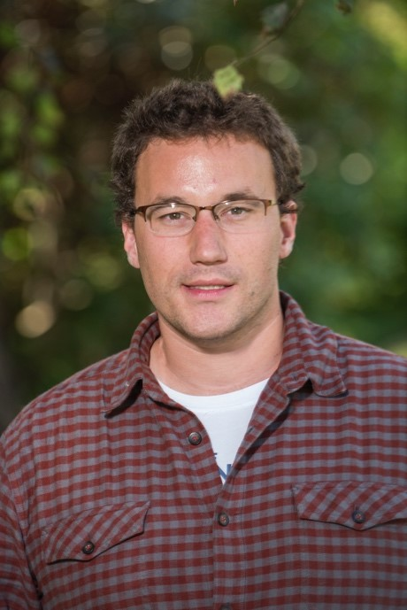

**John W. Steele, Ph.D.**

**Assistant Professor**

**Humboldt State University**

**Understanding how human neurons regulate their cellular environments, survive injuries, and discard cytotoxic materials, while living in a complex three-dimensional structure for decades, is essential to our efforts to develop new and better drugs for human neurodegenerative diseases. The autophagy pathway, a conserved cellular pathway that degrades long-lived proteins, protein aggregates, and damaged cellular organelles, is an essential mechanism for cellular maintenance, defense against nutrient deprivation and injury, and disposal of cytotoxic materials in human neurons. Because neurons are post-mitotic cells, they are heavily dependent upon precise and regular activity of the autophagy pathway to prevent or respond to cellular injury and changes in their environment or nutrient load. The failure of this pathway can be catastrophic to human neurons. My lab uses a combination of human induced pluripotent stem cell culture, genome editing, and drug discovery to study the molecular mechanisms that contribute to cellular disease pathologies in sporadic and hereditary neurodegenerative diseases. This seminar will focus on how we use this set of modern tools and model systems to study diseases and pathways with the ultimate goal of understanding and correcting both rare and common forms of neurodegenerative disease.**

**Genome Editing, Drug Discovery, and the Study of Human Neurodegenerative Diseases**

Biological Sciences Seminar Series venue is wheelchair-accessible. Persons who wish to request disability-related accommodations, including sign-language interpreters, should contact the Department of Biological Sciences, c/o [peb112@humboldt.edu](mailto:peb112@humboldt.edu). Please request accommodations at least two days prior to the event. Some attendees may be sensitive to various scents from perfumes, shampoos, soaps, etc. Although optional, please consider refraining from wearing scented products to this event.

Biology Graduate Student Association and Department of Biological Sciences

Fri. 11/3 @4pm in SCI B133

Biology Seminar

[Hours]

(xxx) yyy-yyyy