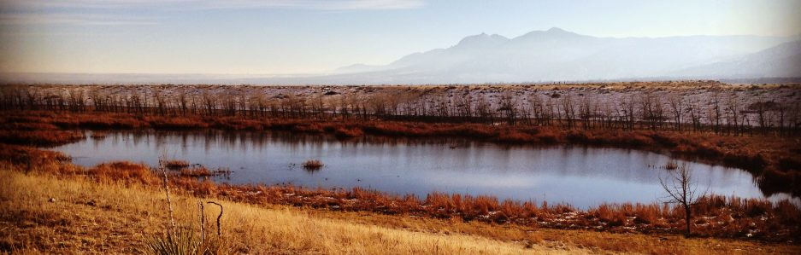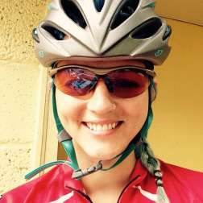

**Mallory Choudoir, PhD**

**Postdoctoral Research Associate**

**University of Colorado Boulder**

**Evolutionary processes and ecological interactions that drive patterns of microbial diversity**

**situ speciation**

Not all microbes are everywhere. Widespread evidence supports the existence of distinct patterns of microbial biogeography, yet the evolutionary and ecological processes that create and maintain these patterns remain evasive. In particular, the influence of dispersal dynamics on microbial biogeography is poorly understood. I explored these questions using a culture collection of over 1,000 *Streptomyces* strains isolated from grassland sites spanning the United States. Using population genetic and genomic approaches, I found strong evidence of dispersal limitations that result in a latitudinal diversity gradient, an observation widely described in plant and animal species but largely undocumented in terrestrial bacteria. I also found phenotypic and genomic evidence in support of historical demographic processes precipitated by post-glacial expansion dynamics in the late Pleistocene creating patterns of contemporary biogeography. More recently, I’ve explored the dispersal capabilities and geographic range size for over 70,000 dust-associated microbial taxa and found that most taxa have small and very few have large ranges. I also identified phenotypic traits and genomic attributes associated with large ranges. These data highlight the importance of historical demography and dispersal capabilities in creating patterns of microbial biogeography.

Biological Sciences Seminar Series venue is wheelchair-accessible. Persons who wish to request disability-related accommodations, including sign-language interpreters, should contact the Department of Biological Sciences, c/o [peb112@humboldt.edu](mailto:peb112@humboldt.edu). Please request accommodations at least two days prior to the event. Some attendees may be sensitive to various scents from perfumes, shampoos, soaps, etc. Although optional, please consider refraining from wearing scented products to this event.

Biology Graduate Student Association and Department of Biological Sciences

Fri. 10/13/17 @4pm in SCI B133

Biology Seminar

[Hours]

(xxx) yyy-yyyy